Notes on the Volunteer’s Database – Participation to an event

Creation of an event and invitation of Volunteers
A Regional User can create an event and invite registered volunteers from the region to the event. 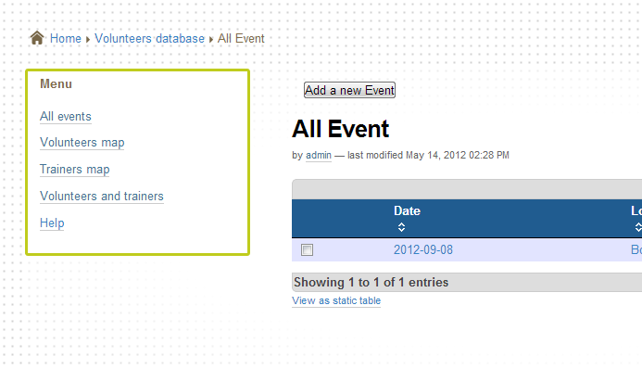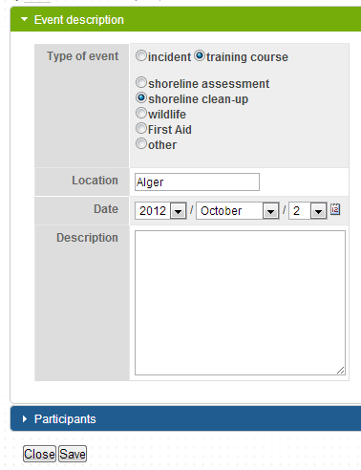
Adding new event
And description
After creating the event, the regional user can add new participants from the database:
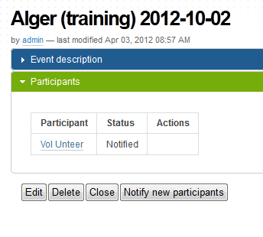
A notification email is sent to the volunteers. After the event, the regional user can edit the information on the training he organised, and insert the training certificate number in the volunteers profile:
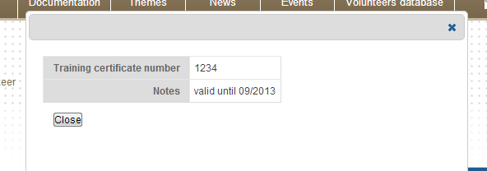

The regional user has access to the volunteers profile of the region, and can ammend/delete the regional data as necessary.

Registration and participation to events by Volunteers
A volunteer has to create an account (email + password) to integrate the database, giving basic information on his skills and geographical localisation:
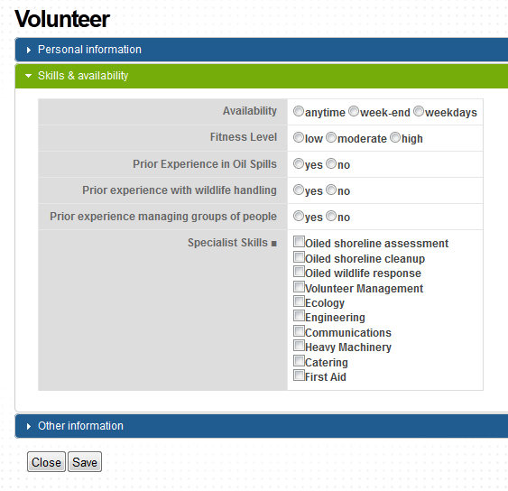
The volunteer can then consult the events organised in his/her country, and participate by registering or accepting an invitation to an event.
After participating to the event, the volunteer shall go back to his/her profile and update his skills & availability information. For instance a new skill can be added after a training.

National Users

The national users are provided with a consultative access enabling them to view (read only) the data for its own country. They can create events and invite volunteers from their country as done by the regional users.

